Practical Assignment 5: K-Means clustering/ hierarchical clustering

[CO1, CO3, BT: L3 (Apply)] [Max Marks: 10]

Problem Definition: Implement K-Means clustering/ hierarchical clustering on sales_data_sample.csv dataset.
Determine the number of clusters using the elbow method.
Dataset link: https://www.kaggle.com/datasets/kyanyoga/sample-sales-data
Theory:
The aim of this experiment is to implement the K-Nearest Neighbors algorithm on the PIMA Indians Diabetes Dataset to classify whether a patient is diabetic or not based on given medical parameters. The dataset contains diagnostic measurements such as glucose level, blood pressure, insulin level, body mass index (BMI), and others. The model will be trained and tested to evaluate its classification performance using metrics like confusion matrix, accuracy, error rate, precision, and recall.
1. Dataset Description:
The dataset used is sales_data_sample.csv (from Kaggle), which contains sales transactions data of a company. It includes details about customers, products, sales, orders, and geographical information.
Attributes in diabetes.csv:
Attribute | Description
ORDERNUMBER | Unique identifier for each sales order.
QUANTITYORDERED | Quantity of items ordered in the transaction.
PRICEEACH | Price of a single item.
ORDERLINENUMBER | Order line sequence number within the order.
SALES | Total sales amount for the order line (Quantity × Price).
ORDERDATE | Date when the order was placed.
STATUS | Status of the order (e.g., Shipped, Cancelled, On Hold).
QTR_ID | Quarter of the year in which the order was placed.
MONTH_ID | Month (numeric) of the order.
YEAR_ID | Year in which the order was placed.
PRODUCTLINE | Category of the product (e.g., Classic Cars, Motorcycles, Trucks, Ships, Trains).
MSRP | Manufacturer’s Suggested Retail Price.
PRODUCTCODE | Unique code for the product.
CUSTOMERNAME | Name of the customer.
PHONE | Contact number of the customer.
ADDRESSLINE1/2 | Address details of the customer.
CITY | City of the customer.
STATE | State/Province of the customer.
POSTALCODE | Postal/ZIP code.
COUNTRY | Country of the customer.
TERRITORY | Sales territory.
CONTACTLASTNAME | Contact person’s last name.
CONTACTFIRSTNAME | Contact person’s first name.
DEALSIZE | Size of the deal (Small, Medium, Large).

2. Clustering
- Unsupervised learning technique that groups similar data points.
- Helps in customer segmentation, anomaly detection, sales analysis.
2.1 K-Means Clustering
- Partitioning method where dataset is divided into K clusters.
- Steps: Initialize centroids → Assign points → Update centroids → Repeat until convergence.
Objective Function (WCSS):
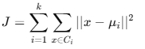
where μi​ is centroid of cluster Ci​.
2.2 Hierarchical Clustering
- Builds nested clusters.
- Agglomerative (bottom-up) and Divisive (top-down) approaches.
- Represented using dendrogram.
Elbow Method
- Plots WCSS vs K.
- The "elbow point" indicates the optimal number of clusters.
Mathematical Model
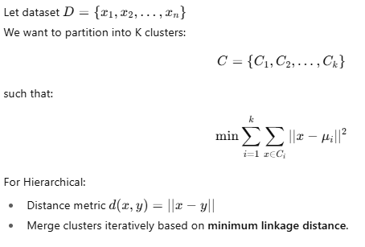
Model Evaluation Metrics:
- Within-Cluster-Sum of Squares (WCSS) – Compactness of clusters.
- Silhouette Score – Quality of clustering:
s= {b-a}/max(a,b)​
where a = intra-cluster distance, b = nearest cluster distance.
Algorithm
K-Means Algorithm
- Choose number of clusters K.
- Randomly initialize centroids.
- Assign each data point to nearest centroid.
- Update centroids as mean of assigned points.
- Repeat until centroids stabilize.
Hierarchical Algorithm (Agglomerative)
- Start with each point as a single cluster.
- Merge two closest clusters based on linkage distance.
- Repeat until only one cluster remains.
- Cut dendrogram at chosen level to form clusters.

Expected Results (Screen Shots of Output)
- Elbow Method graph shows optimal clusters (likely 3–5).
- K-Means groups sales data into clusters (e.g., high-value, medium-value, low-value customers).
- Hierarchical Dendrogram shows hierarchical grouping.
- Segmentation provides useful business insights.
Conclusion
- K-Means provides efficient partition-based clustering for sales data.
- Hierarchical clustering provides tree-based structure useful for visualization.
- Elbow method determines optimal number of clusters for meaningful segmentation.
- Clustering results can help in customer profiling, product strategy, and revenue analysis.

